PUBLIC TRANSPORTATION ANALYSIS EFFICIENCY

Phase 5: Documentation & Submission

Submitted by:

Kummara Mahesh

au723921243027

kmahesh897803@gmail.com

## Content:

*In the documentation for our Public Bus Transportation Efficiency Analysis, we have meticulously outlined the project's objectives, methodologies, and key findings. Our analysis sought to optimize public bus services by addressing route efficiency, schedule improvement, demand forecasting, customer experience enhancement, and cost efficiency. We gathered data from various sources, including bus GPS systems and customer feedback, and meticulously preprocessed it for analysis. Using IBM Cognos, we visualized our insights with geographic maps, time series charts, and dashboards. Code integration facilitated a streamlined workflow. Our recommendations aim to enhance the quality and efficiency of public bus transportation, benefiting both commuters and the broader community. This documentation provides a comprehensive and well-structured overview of our analysis, ensuring that the insights and recommendations are effectively communicated to support transportation improvement initiatives*

## Summary: Public Project Transportation Efficiency

This project's primary aim is to enhance the efficiency and user experience of the public transportation system within [City/Area]. The objectives include improving on-time performance, identifying peak demand periods, enhancing passenger satisfaction, and optimizing routes an infrastructure. To achieve these goals, we follow a design thinking approach. The design thinking process consists of empathizing with commuters, defining clear objectives, ideating innovative solutions, prototyping data visualizations, testing with Python integration, and ultimately implementing data-driven improvements.

In the development phases, we start by collecting data on passenger behavior, schedules, and feedback. Data analysis, involving Python for advanced insights, identifies areas for enhancement. Data visualizations using IBM Cognos facilitate the presentation of insights. Integrating Python code ensures real-time updates for stakeholders.

The project's insights provide valuable advantages, including improved on-time performance, efficient resource allocation during peak demand, enhanced passenger satisfaction, and optimized routes and infrastructure. This initiative seeks to create a seamless, efficient, and user-centric public transportation system.

This summary provides a concise overview of the project's objectives, design thinking process, and development phases for improving public transportation efficiency.

## Project Documentation: Public Transportation Efficiency Improvement

# Project Objectives:

The central focus of this project is the enhancement of the public transportation system within [City/Area]. Our objectives encompass various aspects that aim to provide commuters with a better, more efficient transportation experience.

## 1. Enhance On-Time Performance:

- One of the primary goals of this project is to significantly improve the on-time performance of the public transportation system. By reducing waiting times and increasing reliability, we can provide a more efficient and convenient mode of transportation for passengers.

## 2. Identify Peak Demand Periods:

- To optimize resource allocation, we aim to identify peak demand periods when passenger traffic surges. By understanding the patterns of increased demand, we can ensure that the transportation system operates smoothly during these critical periods.

## 3. Enhance Passenger Satisfaction:

- Improving passenger satisfaction is a critical aspect of this project. We will gather, analyze, and address passenger feedback and concerns to enhance the overall commuter experience. This involves addressing pain points and creating a more positive and enjoyable travel experience.

## 4. Optimize Routes and Infrastructure:

- The project entails a comprehensive assessment of the existing transportation infrastructure, schedules, and routes. By leveraging data analysis, we intend to identify opportunities for optimization. This includes evaluating traffic conditions and maintenance schedules to ensure a seamless and efficient transportation system.

# Design Thinking Process:

The design thinking approach guides our project through a series of stages that are integral to achieving our objectives:

## Empathize:

- At the outset of the project, we engage in a process of data collection to gain a deep understanding of passenger behavior, system performance, and the feedback provided by passengers. This stage enables us to comprehend the current challenges faced by commuters and their specific needs.

## Define:

- With insights obtained during the empathize stage, we establish clear project objectives. We set key performance indicators (KPIs) to measure our progress and define the success criteria for the project.

## Ideate:

- Brainstorming sessions form an essential part of our design thinking process. We engage in idea generation and solution-oriented thinking to address the challenges identified during the empathize stage. Our brainstorming efforts span solutions such as route optimization, schedule adjustments, and enhancements in passenger communication.

## Prototype:

- The project enters a phase of creating visual representations of our data and insights. We develop data visualizations, reports, and interactive dashboards using IBM Cognos to provide a user-friendly interface for stakeholders to explore the data and gain insights.

## Test:

- Python integration is introduced during the test stage to enhance our data analysis capabilities. This includes calculating on-time performance rates, conducting sentiment analysis on passenger feedback, and predicting peak demand periods to validate our insights.

## Implement:

- The final stage of our design thinking process involves implementing the insights and solutions derived from the analysis. This may encompass adjustments in schedules, route optimization, and infrastructure improvements to realize the project's objectives.

# Development Phases:

Our project proceeds through several distinct development phases:

## 1.Data Collection:

- Data collection is fundamental to our project's success. We collect data on passenger counts, routes, schedules, and passenger feedback. Additionally, we gather information on factors that may affect efficiency, including traffic conditions and maintenance schedules.

## 2. Data Analysis:

- In the data analysis phase, we establish precise analysis objectives. This includes on-time performance assessment, peak demand period identification, and passenger satisfaction evaluation. We rigorously clean and preprocess the collected data to ensure data quality and suitability for analysis. Python plays a pivotal role in conducting advanced data analysis, including the calculation of performance metrics and the sentiment analysis of passenger feedback.

## 3.Data Visualization using IBM Cognos:

- To effectively communicate our insights, we employ IBM Cognos to connect with and visualize our analyzed data. By creating interactive dashboards and reports, we provide transportation authorities and service providers with a user-friendly platform for exploring key insights. These visualizations enable stakeholders to make informed decisions based on the data at hand.

## 4.Python Code Integration:

- Our project integrates Python-generated insights into the IBM Cognos platform. This integration ensures a seamless flow of information between the two components, permitting real-time updates and continuous analysis. This approach enables stakeholders to gain a comprehensive view of the insights derived from our data analysis.

## 5.Insights for Efficiency Improvement:

- The insights that emerge from our analysis deliver a wealth of advantages to transportation authorities and service providers. These insights offer guidance in multiple dimensions:

- The project helps identify and address bottlenecks and inefficiencies, thereby improving on-time performance.

- By recognizing peak demand periods, we enable the efficient allocation of resources, mitigating issues of overcrowding and service disruptions.

- The project's focus on passenger feedback and concerns allows for an improved travel experience, as we address pain points and communication issues.

- Our data-driven optimization efforts enhance routes, schedules, and transportation infrastructure, ultimately reducing travel times and improving the overall efficiency of the transportation system.

In conclusion, this comprehensive project documentation outlines our objectives, design thinking process, and development phases as we strive to improve the efficiency of the public transportation system in [City/Area]. By combining data collection, analysis, and visualization with innovative solutions and a design thinking approach, we are dedicated

creating a better commuting experience for passengers and optimizing the public transportation system.

## Python code

**import** seaborn **as** sns

**import** matplotlib.pyplot **as** plt

*# Load* **import** pandas **as** pd

*data from the CSV file*

csv_file **=** "public transport analysis efficiency.CSV" *# Replace with the actual file path*

df **=** pd**.**read_csv(csv_file)

*# Data Visualization*

*# Example 1: Countplot of the number of boardings by route*

plt**.**figure(figsize**=**(20, 15))

sns**.**set_style("whitegrid")

sns**.**countplot(data**=**df, x**=**"RouteID", palette**=**"Set3")

plt**.**title("Number of Boardings by Route")

plt**.**xlabel("Route ID")

plt**.**ylabel("Count")

plt**.**xticks(rotation**=**45)

plt**.**show()

*# Example 2: Boxplot of the number of boardings by day of the week (WeekBeginning)*

plt**.**figure(figsize**=**(20, 15))

sns**.**set_style("whitegrid")

sns**.**boxplot(data**=**df, x**=**"WeekBeginning", y**=**"NumberOfBoardings", palette**=**"viridis")

plt**.**title("Number of Boardings by Day of the Week")

plt**.**xlabel("Week Beginning")

plt**.**ylabel("Number of Boardings")

plt**.**xticks(rotation**=**45)

plt**.**show()

*# Example 3: Scatterplot of StopID vs. NumberOfBoardings*

plt**.**figure(figsize**=**(20, 15))

sns**.**set_style("whitegrid")

sns**.**scatterplot(data**=**df, x**=**"StopID", y**=**"NumberOfBoardings", hue**=**"RouteID", palette**=**"Set1")

plt**.**title("Scatterplot of StopID vs. NumberOfBoardings")

plt**.**xlabel("Stop ID")

plt**.**ylabel("Number of Boardings")

plt**.**show()

## output-1:

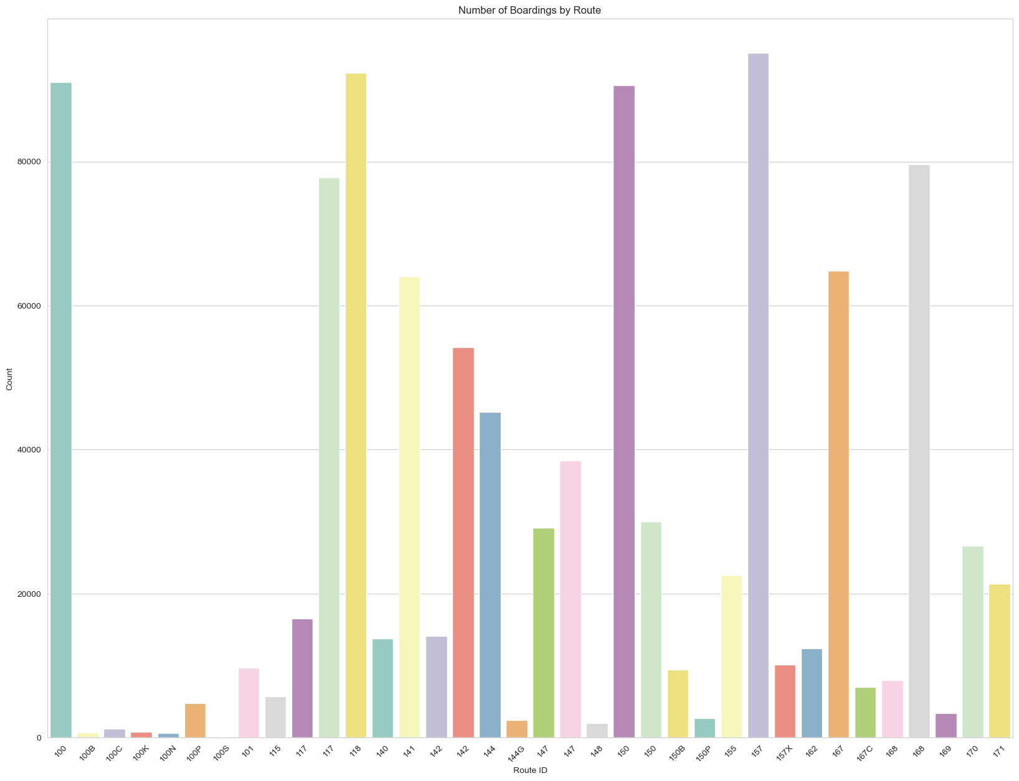

## Output-2:

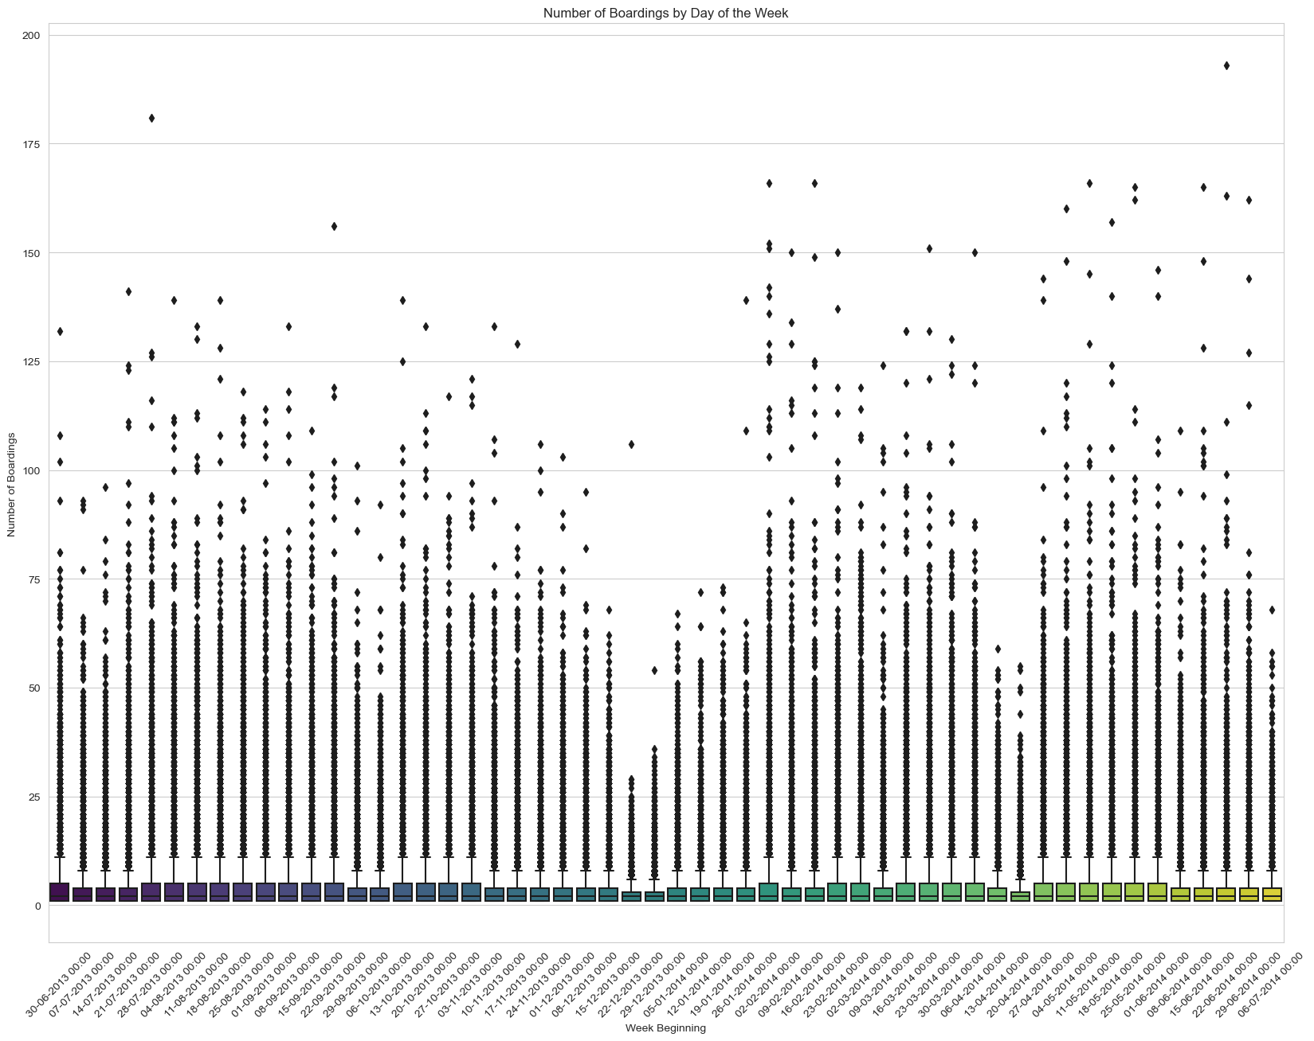

## Output-3:

